**Name:- Chaudhari Girish Ravindra**

**Class:- MCA-I(A) Roll no:-11 Sub:- DBMS**

**Assignment no:- 1. Practice problem- CREATE TABLE**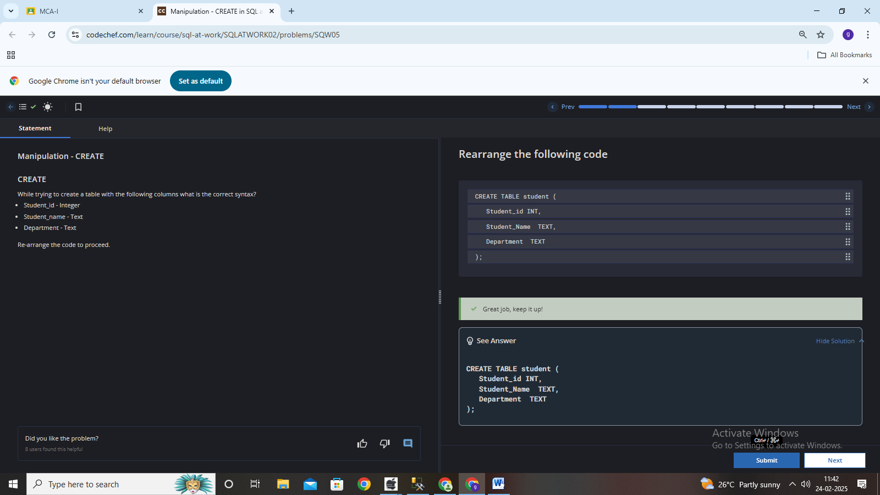

**2. Practice problem- ALTER and UPDATE**

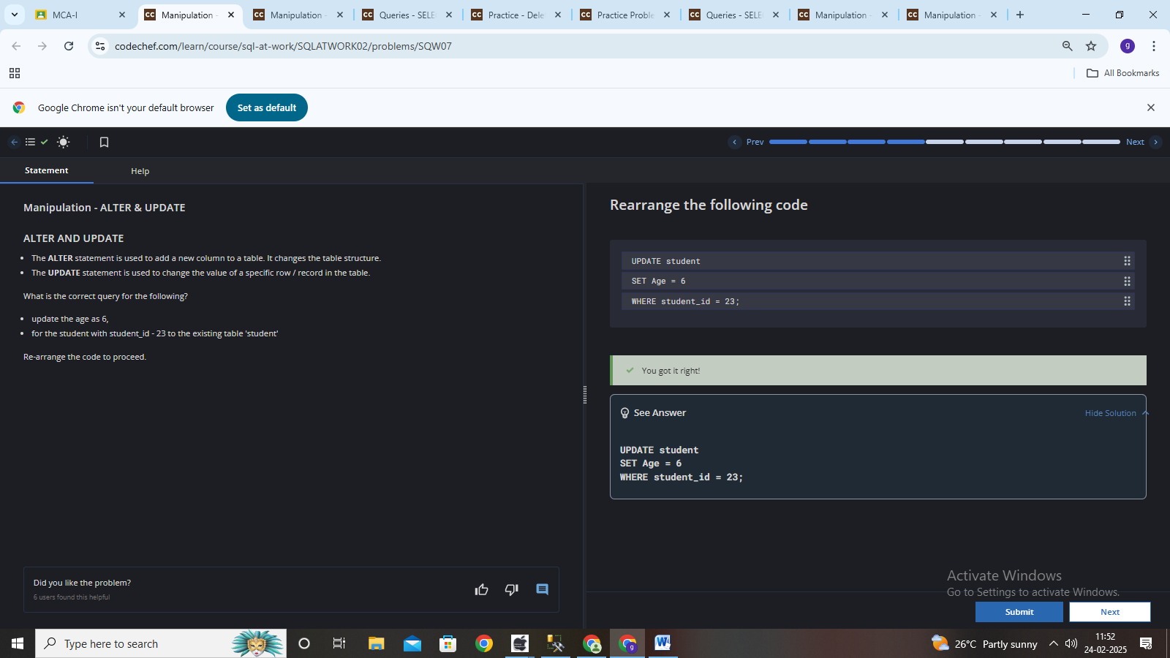

**3. Practice problem- SELECT QUERY**

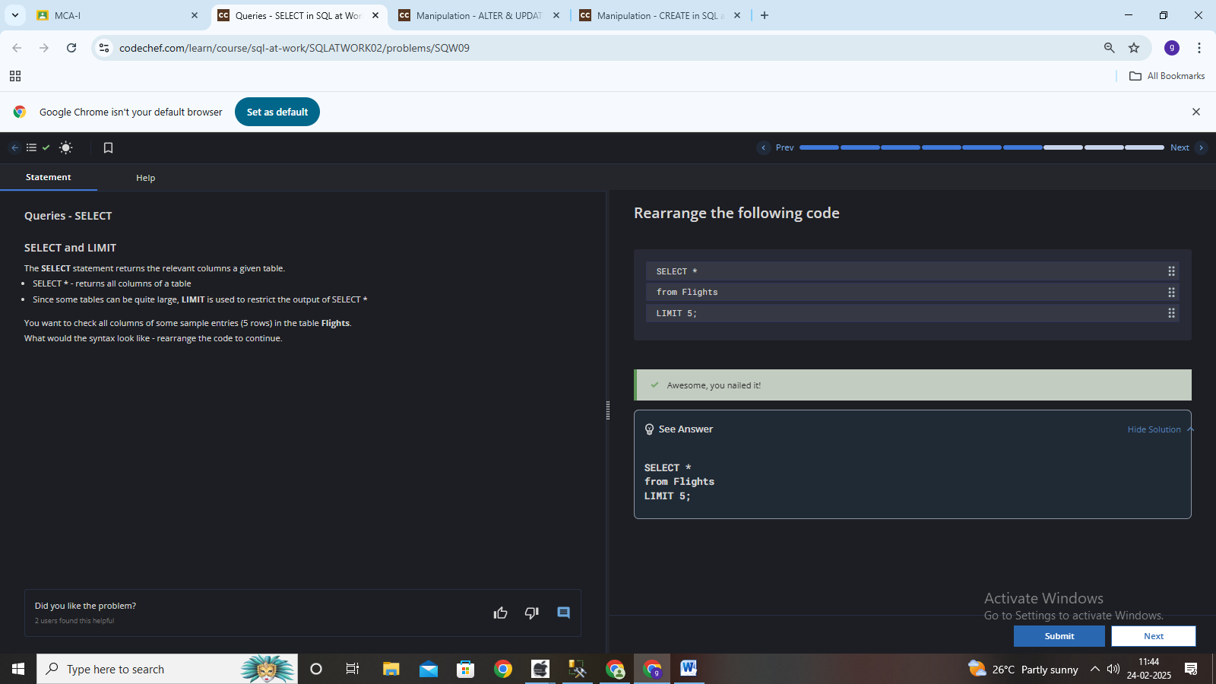

**4. Practice problem- ALTER TABLE**

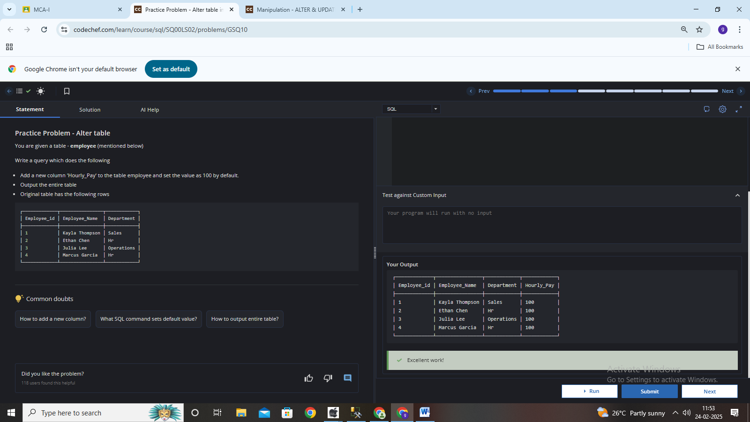

**5. Practice problem- DELETE QUERY**

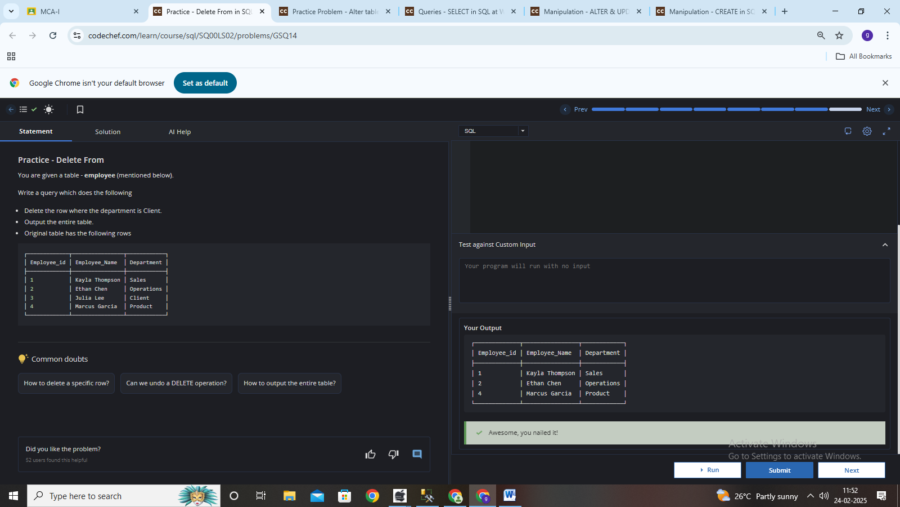

**Practical-2 DML Statements**

**6. Practice problem- DELETE DUPLICATED QUERY**

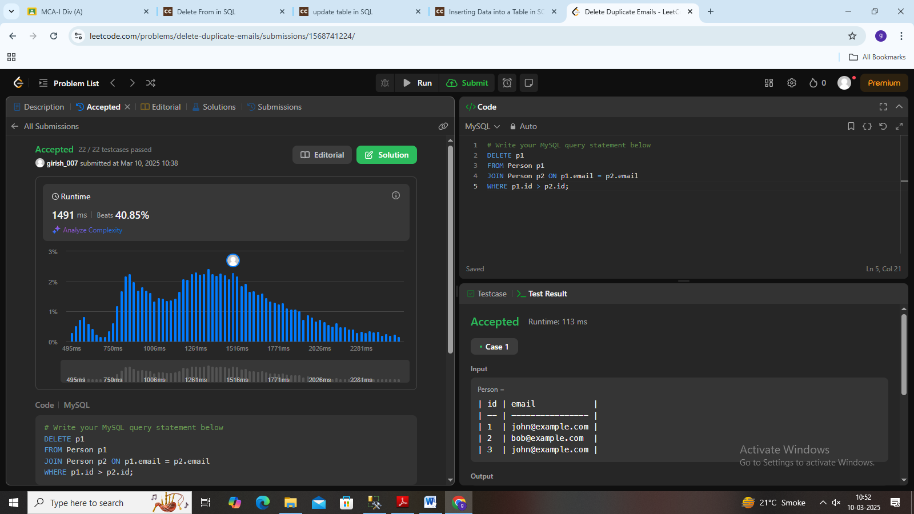

**7** **Practice problem:-** **Inserting Data into a Table**

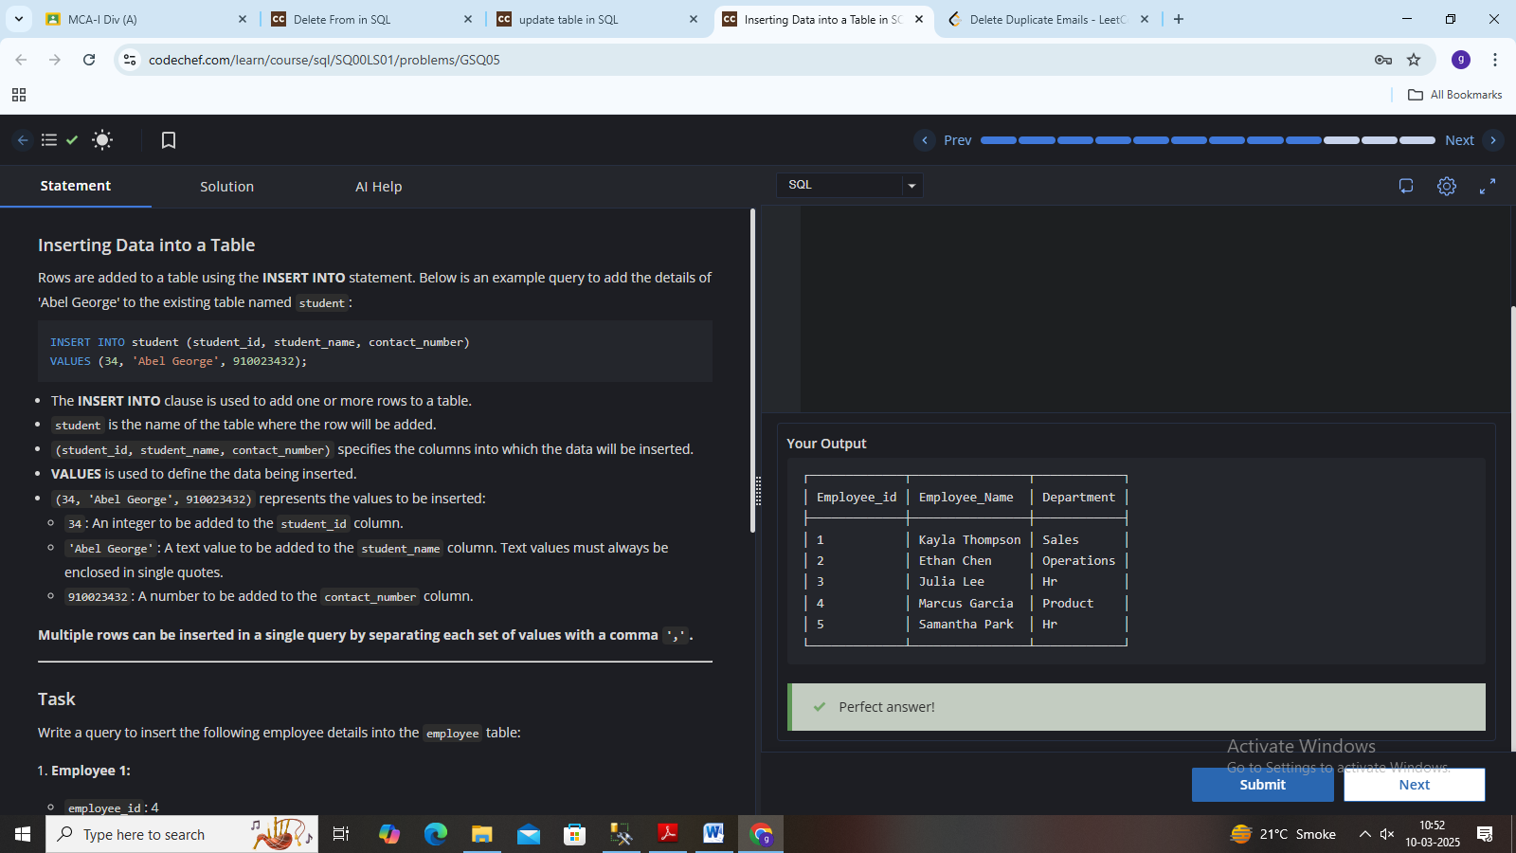

**8 Practice problem:- Update Table**

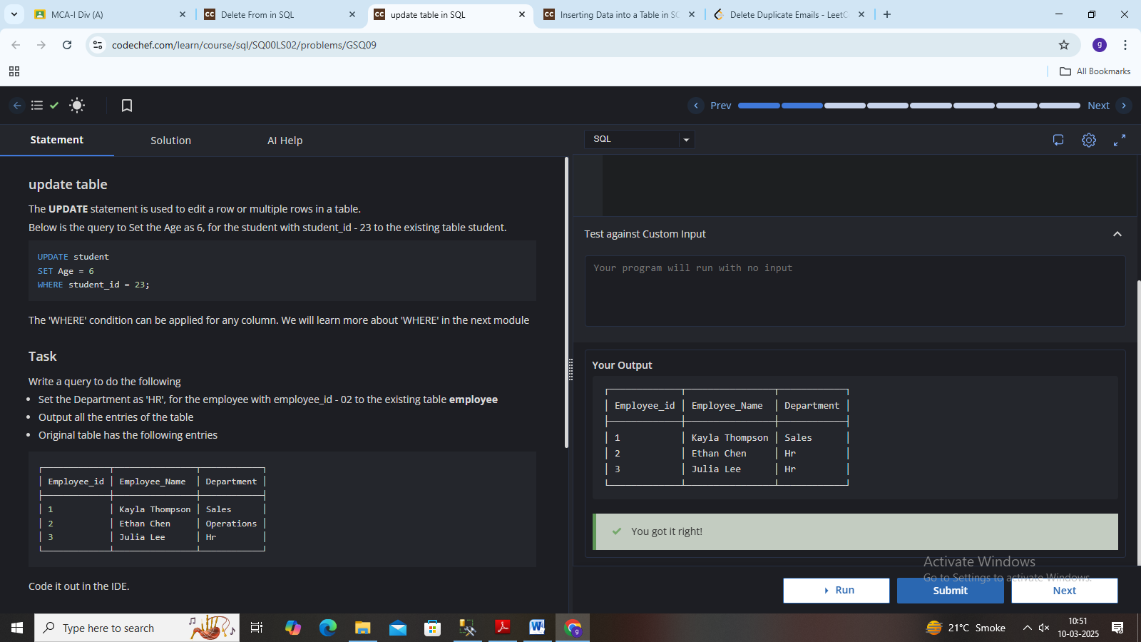

**9. Practice problem:- Delete Query**

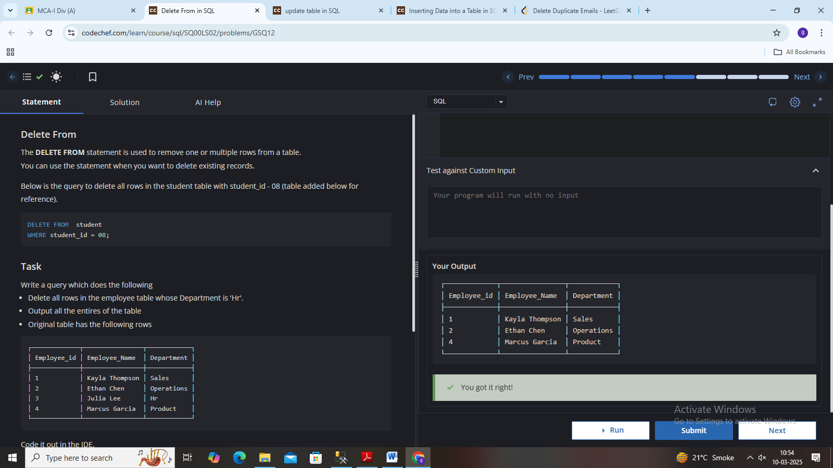

**10. Practice problem:- Alter Query**

